Drafting 20 Isometric Projects
Definition: Taking the three views of orthographic to make an isometric projection or a 3-D image,
1. Review (basic) video on Isometric: https://www.youtube.com/watch?v=tvGoN4XFlrk
2. Practice – as she shows you the steps.... https://www.youtube.com/watch?v=7-BzAnamtro
Online graph paper and drawing tool:
https://www.nctm.org/Classroom-Resources/Illuminations/Interactives/Isometric-Drawing-Tool/
Or...if this works better
You may use/print/download Isometric Graph Paper: https://www.teachengineering.org/content/cub_/activities/cub_spatviz/cub_spatviz_lesson01_activity1_isometric-paper.pdf (this graph paper enables us to get the correct angles for isometric}

3. Isometric drawing 1 – Title: The Doorstop https://www.youtube.com/watch?v=AA1Vxc5_nUI&t=10s

4. Isometric drawing 2 - Continue practice Engineering 6 – Isometric Sketch Exercise
https://www.youtube.com/watch?v=sSuyM60s7eA

5. Matching – take the three views(orthographic) & match them with the correct isometric 3-D image
Isometric matching worksheet: see the next page

6. Drawing Projects for isometric: You may complete these on the paper grid that is given in each questions.
Isometric 1 Drawing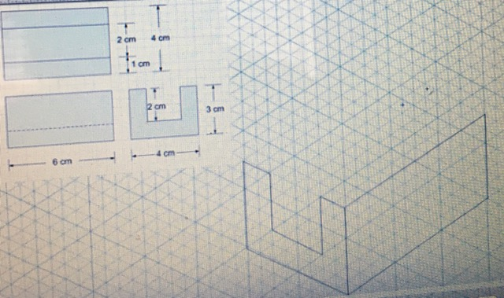
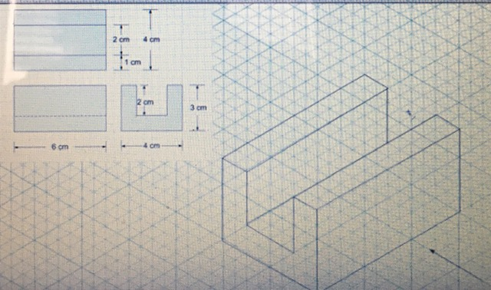Self check...does yours look like this? Marnz

Isometric 2 Drawing - you can use this box that is given to you or isometric graph paper or the Illuminations.
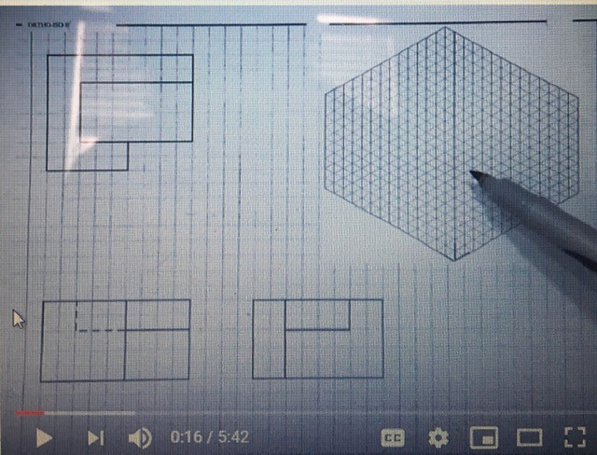
Handwork Hints and Help 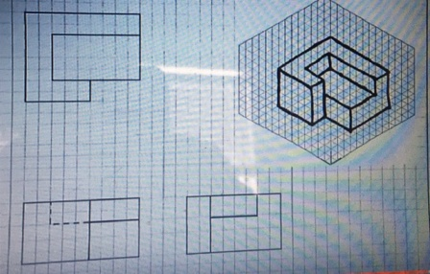 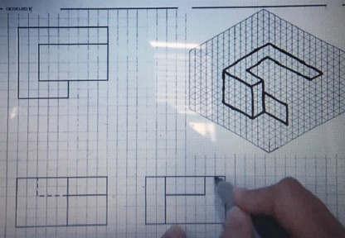 Voila!

TRY THESE!!!! WITH GRAPH PAPER OR Illuminations or print this out.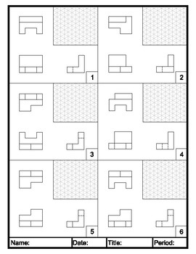
Isometric Matching Project for Drafting 20 (Question 5)
