DRAFTING 10 INTRODUCTION TO 3-D Name: ______________________
Attributes (the basis of 2-D) can include color, shape, straight line, curved line, and size but also the following, give the definition of each:
Vertex -
Edge -
Face -
Name of Shape | ATTRIBUTES how many faces, edges and vertices | SKETCH | Scavenger Hunt around home: Real world Example 1 (Just list; not draw) | Real world Example 2 (Just list, not draw)
cone
cylinder
Rectangular prism
cube
Rectangular prism
Square based pyramid
Sphere

And many many more

What about combined 3-d shapes?? Think about these: Complete the chart.
Item | Combined 3-D shapes | Sketch
Microphone | Cone and sphere  Or cylinder and sphere
 |  | 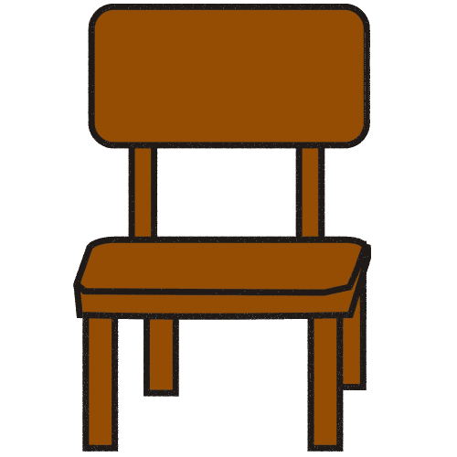
 | Two rectangular prisms
Ice cream cone
 |  | 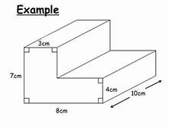
Basic house
 |  | 