Drafting 20 Orthographic Sketches – Your turn
Look at the 3-D object and sketch or draw on separate sheet of paper or electronic graphic paper. Remember to label and include: Top, Front and RHS views. +++See the last box for proper alignment
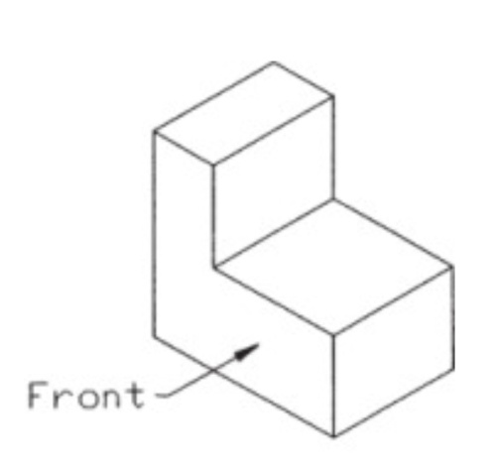1 | 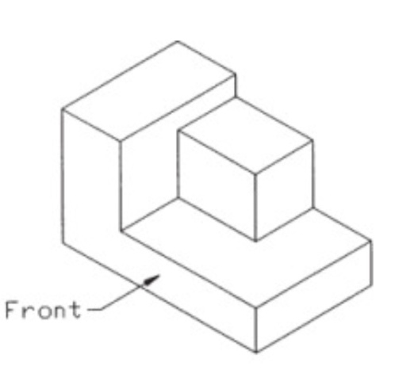2
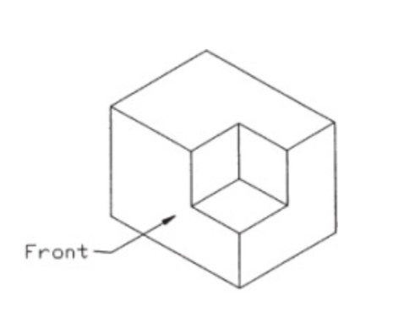3 | 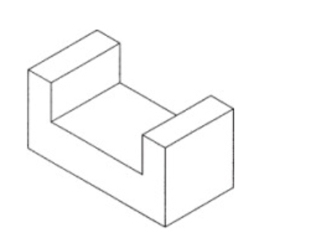4
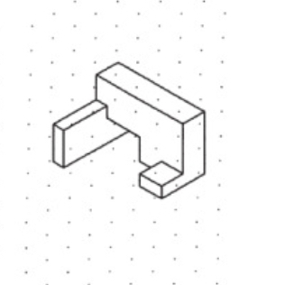5 | 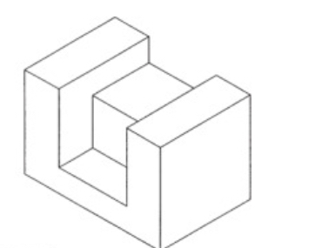6
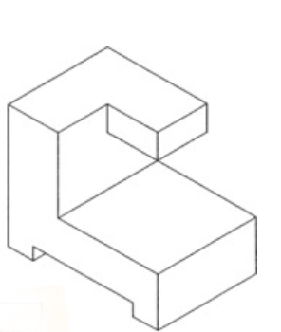7 | 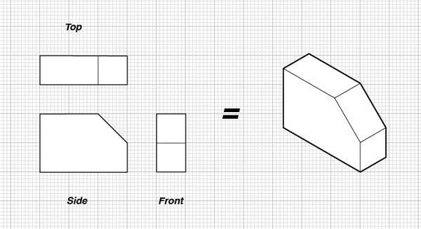
Notice how the views ‘line up’!!!

